**Assignment 14.1**

1. Create the vectors

(a) (2, 3, … , 29, 30)

**ANS: > a=2:30**

**> a**

(b) (30, 29, … , 2)

**ANS: > b = 30:2**

**> b**

(c) (1, 2, 3, …. , 29, 30, 29, 28, , 2, 1)

**ANS: > c = c(1:30,29:2)**

**> c**

(d) (4, 6, 3) and assign it to the name dev.

**ANS: > dev = c(4,6,3)**

**> dev**

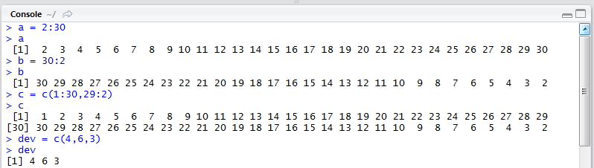

e) (5, 6, 7, 5, 6, 7, , 5, 6, 7) where there are 10 occurrences of 5.

**ANS: > e = c(5:7,5:7,5:7,5,5)**

**> e**

(f) (5, 6, 7, 5, 6, 7, , 5, 6, 7, 5) where there are 11 occurrences of 5, 10 occurrences of 6 and 10 occurrences of 7.

**ANS: > f = c(rep (c(5:7),times=10),5)**

**> f**

(g) (4, 4, , 4, 6, 6, , 6, 3, 3, , 3) where there are 10 occurrences of 4, 20 occurrences

of 6 and 30 occurrences of 3.

**ANS: > g = c(rep(4,10),rep(6,20),rep(3,30)) or c(rep(c(4,6,3),times=c(10,20,30)))**

**> g**

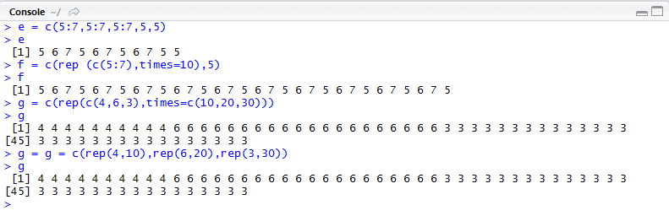

2. Create a vector of the values of e X sin(x) at x = 3, 3.1, 3.2, , 6

**ANS: > JILL = seq(3,6,by=0.1)**

**> exp(JILL)*sin(JILL)**

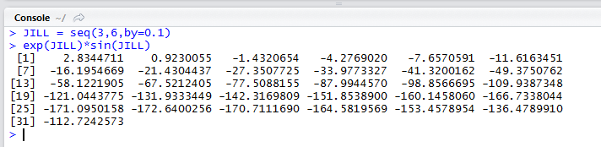

3. Execute the following lines which create two vectors of random integers which are chosen with replacement from the integers 0, 1, : : : , 999. Both vectors have length 250. set.seed(100) x <- Sample (0:999, 250, replace=T) y <- Sample (0:999, 250, replace=T)

**ANS: > x = sample(0:999,250,replace = T)**

**> y = sample(0:999,250,replace = T)**

1. Identify out the values in y which are > 500.

**ANS: > a <- subset (y,y>500)**

**> a**

1. Identify the index positions in y of the values which are > 700?

**ANS:**  **> b <- which(y>700)**

**> b**

c) What are the values in x which are in Same index position to the values in y which

are > 400?

**ANS: > c <- which (y>400)**

**> c**

**> x[c]**

d) How many values in y are within 200 of the maximum value of the terms in y?

**ANS**: **> d = y[y>(max(y)-200)]**

**> d**

e) How many numbers in x are divisible by 2?

**ANS**: **> e = sum(1-x%%2)**

**or**

**> e = sum(x%%2 ==0)**

f) Sort the numbers in the vector x in the order of increasing values in y.

**ANS**: **f1 = y[sort(order(y)[x])]**

g) Create the vector (x1 + 2x2 - x3; x2 + 2x3 -x4 ,, xn−2 + 2xn−1 - xn).

**ANS: > g <- rep (c(0), times=248)**

**> for (i in 3:250){**

**+ g[i-2] <- x[i-2]+ (2*x[i-1]) - x[i]}**

**> g**

h) Calculate: n-1

Σ (e−xi+10/ xi + 10) i=1

**ANS: > h=0**

**> for (i in 1:249){**

**+ h=h+ (exp((-x[i]+10)/x[i]) + 10)}**

**> h**

